Invoice

TAMIL TOURS AND TRAVELS

103A/5, Collector office road

Periya milagubarai,Trichy-1.

Phone : 9790545607, 8072142886

Invoice No :053

Invoice Date:05-05-23

To

K.Ramakrishnan College of Engineering , Samayapuram

|  |  |  |
| --- | --- | --- |
| **S No** | **Details** | **Amount** |
| 1 | Bus, Theme park ticket, Refreshment and Breakfast  ( 130 students X Rs.1600) | 208000 |
|  |  |  |
|  |  |  |
|  |  |  |
|  |  |  |
|  |  |  |
|  |  |  |
|  |  |  |
|  | **Total Value in Words**  **Two lakh and eight thousand rupees only** | **Rs.208000** |

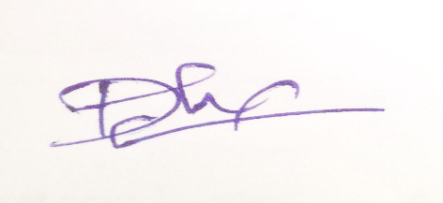

**Authorized Signature for TTT**